**Testing Report**

**Project Name:** Leapify Talk

**Date:** 12-07-2024

**Tester Name:** Sujithra Jayan

**Design Link:** <https://www.figma.com/file/dflaGXC6EfwEYhufOlxtHQ/LeapifyTalk?node-id=1%3A8>

**Testing URL:** <https://musing-saha-2d39c9.netlify.app/>

**Browser**: Chrome at 100% zoom

**Total issues: 35**

1. **Navigation Button Alignment:**

**Design:**



**Actual:**



**Bug:** The navigation buttons are currently left-aligned in Actual Web, whereas the design specifies right alignment.

1. **Spacing Between Sign in and Get Started Buttons:**

**Design:**

**Actual Web:**

**Bug:** There is no space between the "Sign In" and "Get Started" buttons.

1. **Currently Active Page Highlighting:**

**Design:**

******Actual:**

**Bug:** The currently active page is not highlighted in the actual implementation.

1. **Header Panel Colour:**

**Design:**

**Actual:**

**Bug:** The header panel has a different colour compared to the design.

1. **Panel Spacing:**

**Design:**

**Actual:**



**Bug:** There is additional space at the start and end of the panel, in actual whereas the design specifies space only at the start, before the logo.

1. **Logo Image:**

**Design:**

**Actual:**

**Bug:** The actual implementation includes a logo image, which is absent in the design.

1. **Navigation Button Label:**

**Design**:

**Actual:**

**Bug:** The "Counselors Job" button in the actual implementation is labeled "Counselor" in the design, causing confusion.

1. **Font Difference:**

**Design:**

**Actual :**



**Bug:** There is a difference in the font used between the design and the actual implementation.

1. **Font Alignment Issue:**

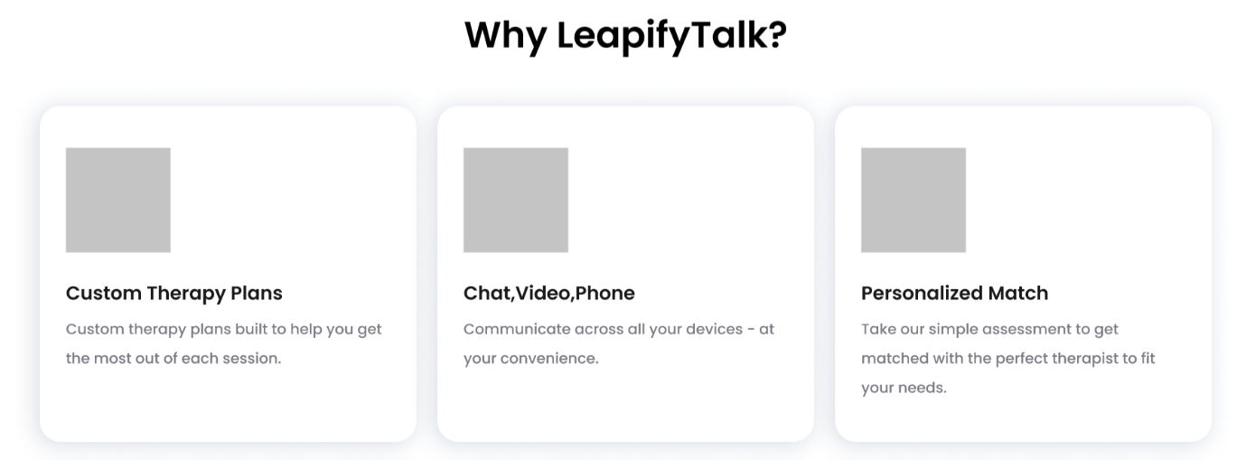**Design:**

**Actual:**

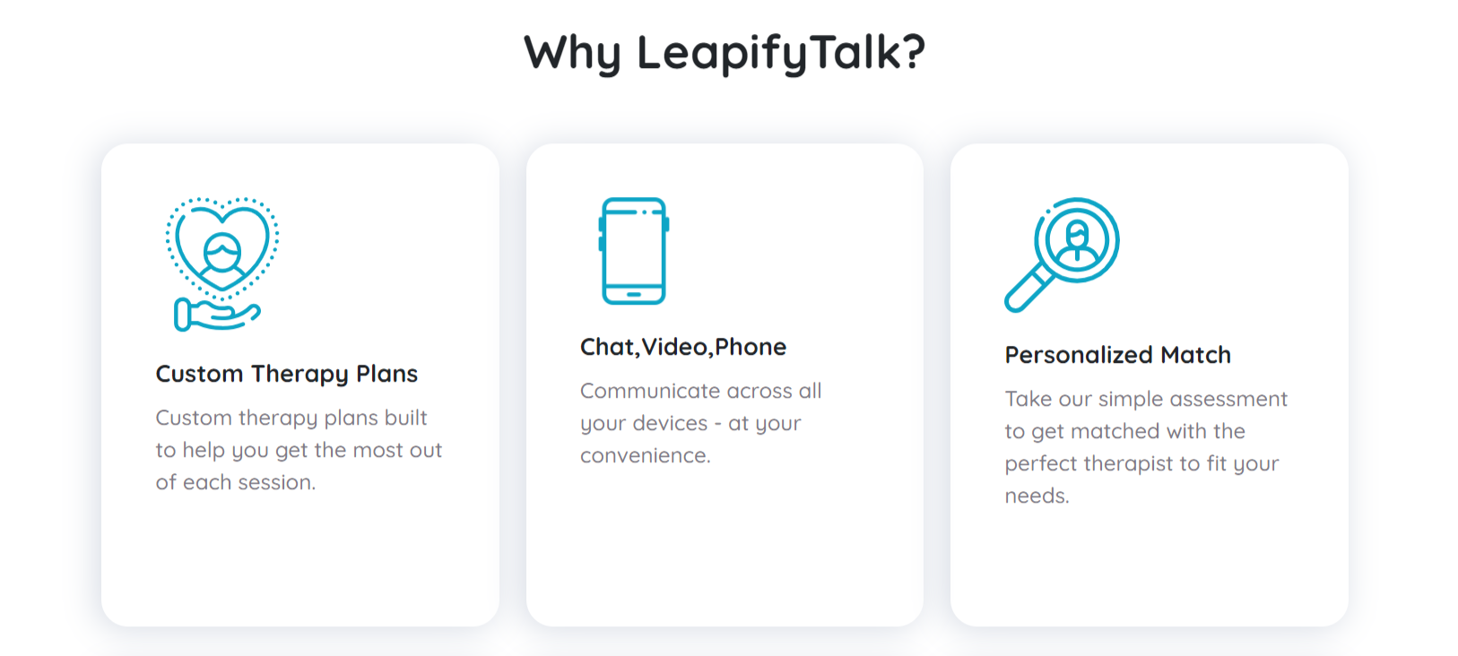

**Bug:** There is a font alignment issue between the design and the actual implementation.

1. **Spacing and Alignment Below Heading:**

**Design:**

**Actual:**

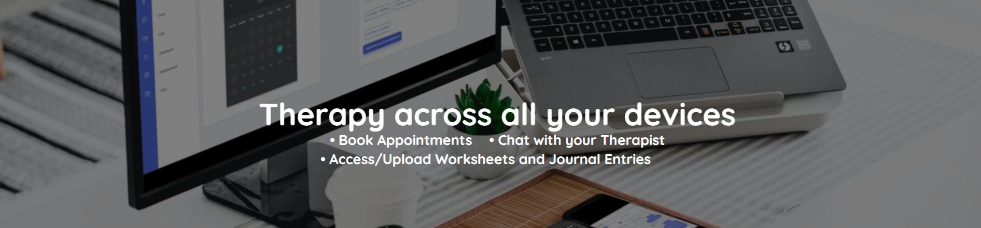

**Bug:** There is no space below the heading and the options are not aligned as in the design.

1. **Navigation Arrow Mark:**

**Design:**

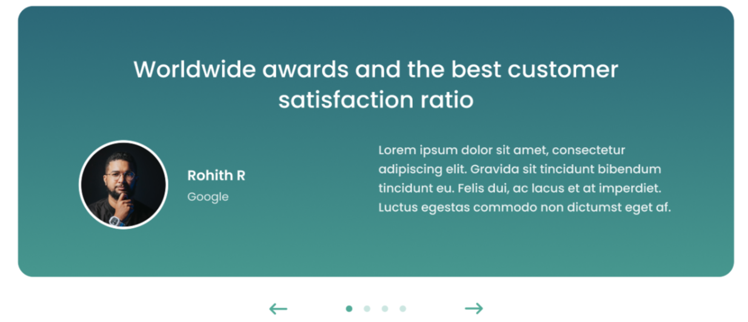

**Actual**: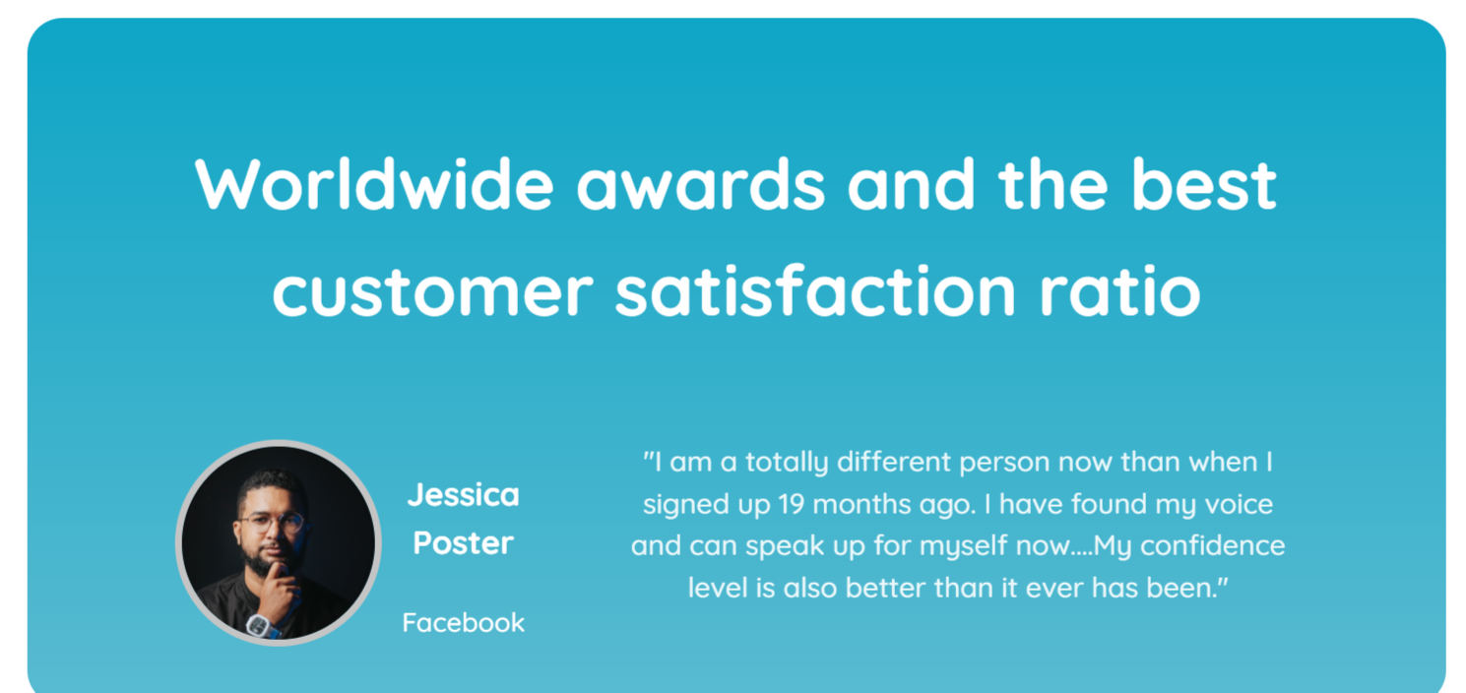

**Bug :** The design includes an arrow mark for navigation, which is missing in the actual implementation.

1. **Icon Differences:**

**Design:**

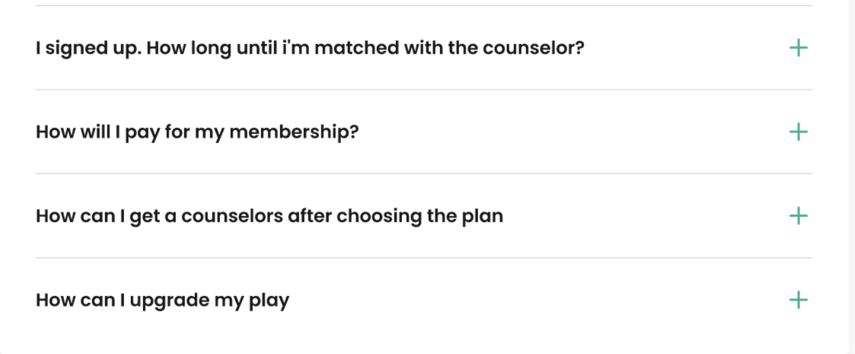

**Actual:**

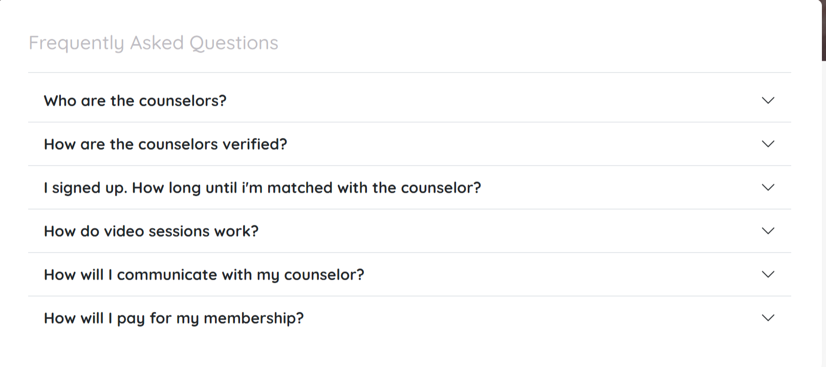

**Bug:** There are differences in icons between the design and the actual implementation.

1. **FAQ Arrangement Difference:**

**Design:**

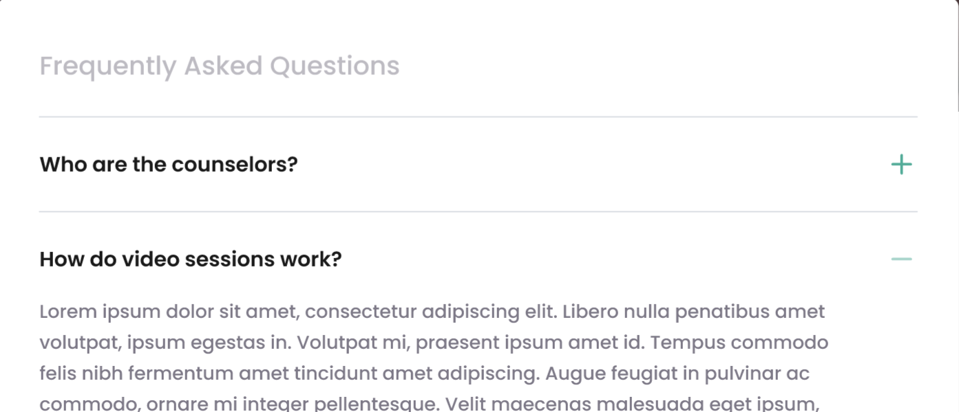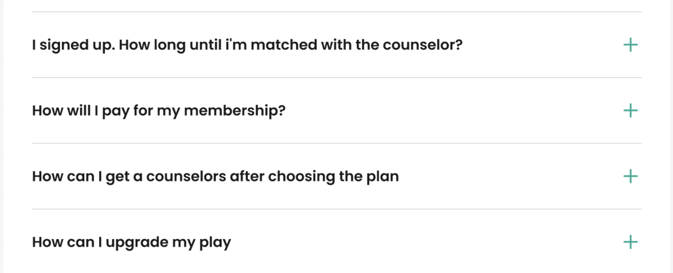

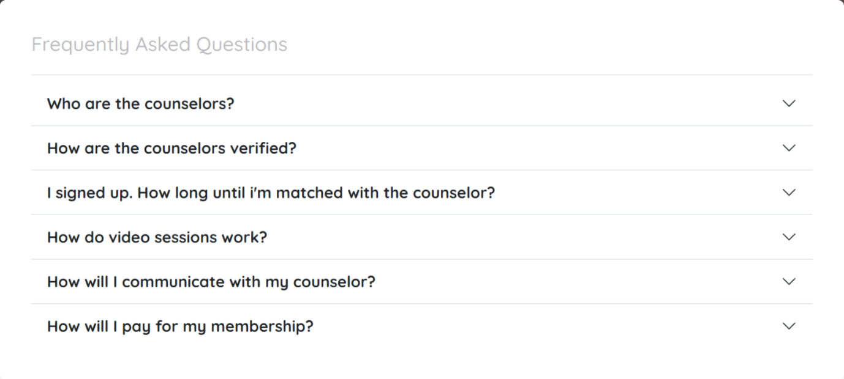**Actual:**

**Bug:** The arrangement of FAQs differs between the design and the actual implementation.

1. **Space Between FAQ Section and Bottom Panel:**

**Design:**



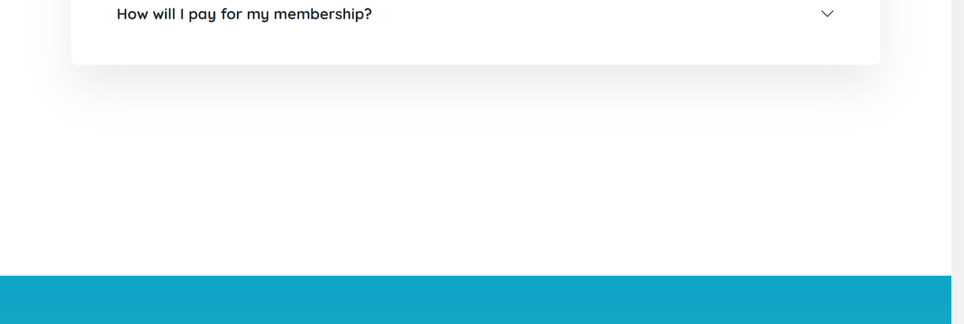**Actual:**

**Bug:** There is additional space between the FAQ section and the bottom panel in the actual implementation compared to the design.

1. **Space at the End of Page:**

**Design:**

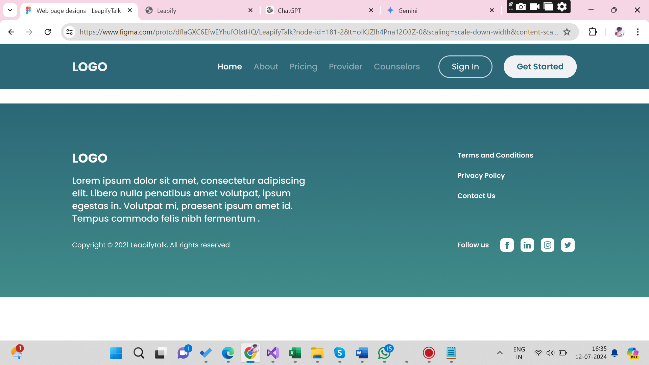

**Actual:**



**Bug:** There is no space at the end of the page in the actual implementation, whereas there is space in the web design.

1. **Bottom Panel Difference:**

**Design:**

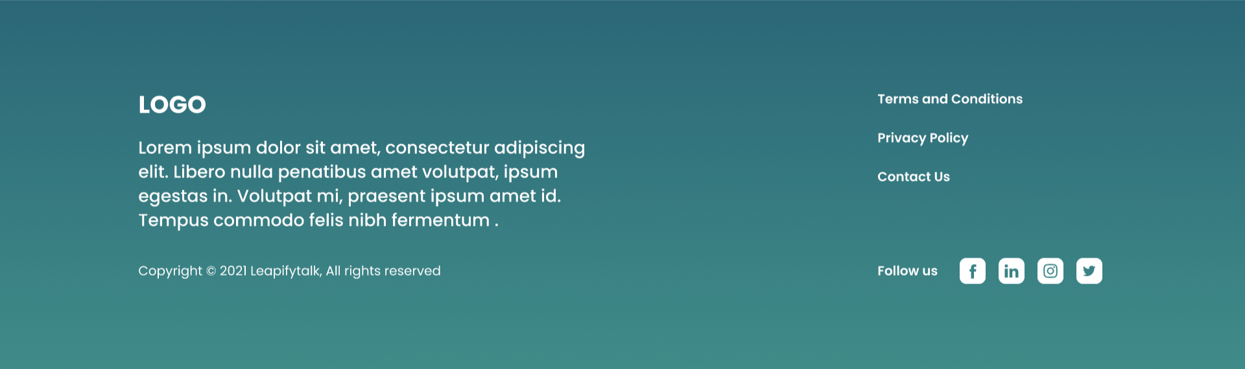

**Actual:**

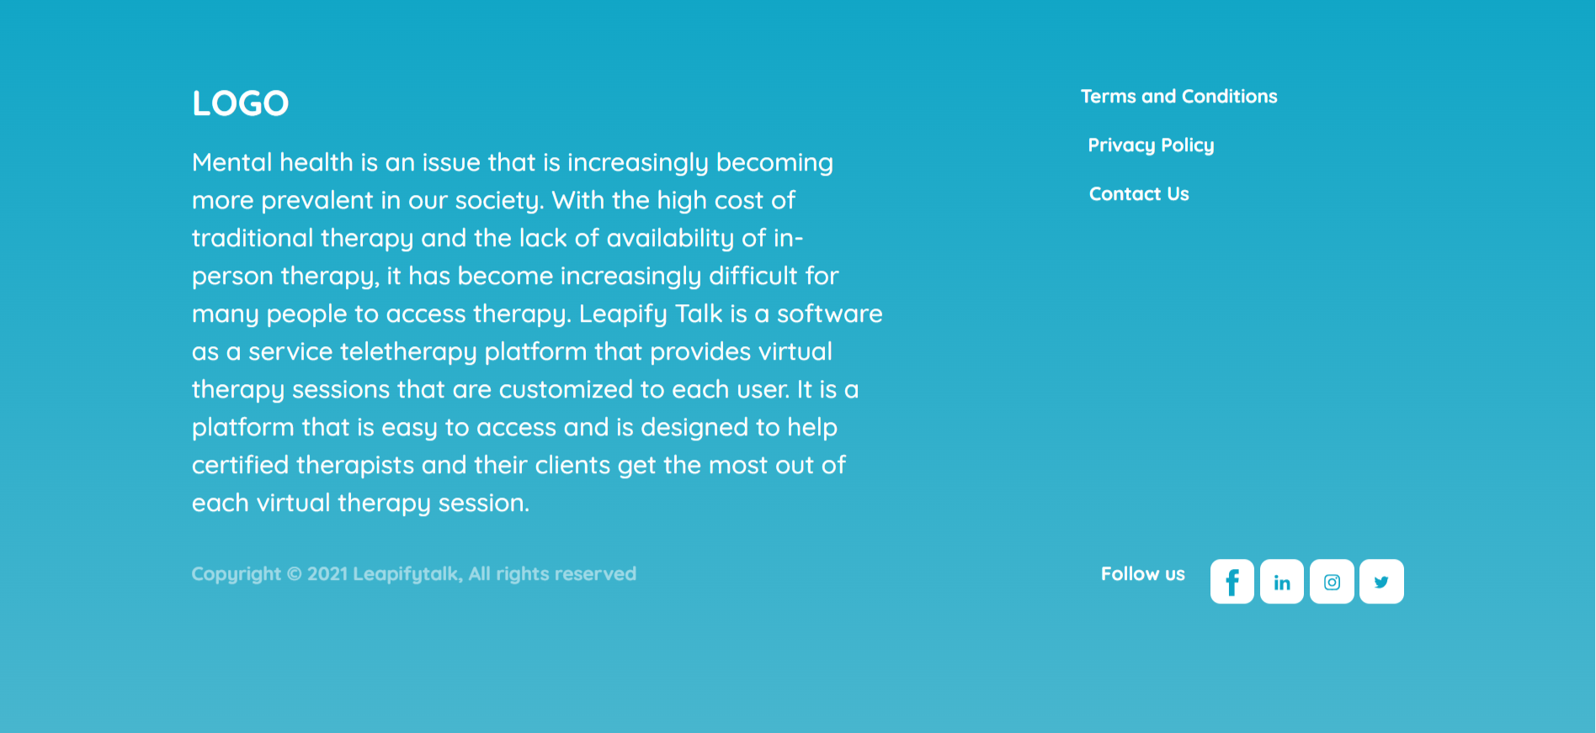

**Bug:** The bottom panel in the actual implementation differs from the design.

1. **Unnecessary Space Between Services:**

**Design:**

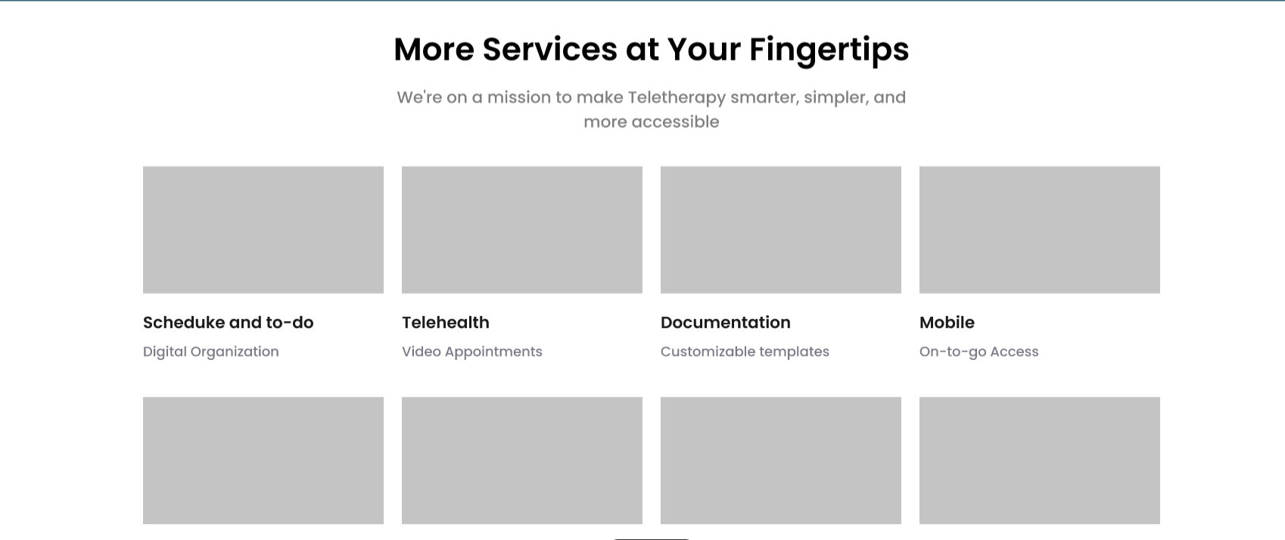

**Actual:**

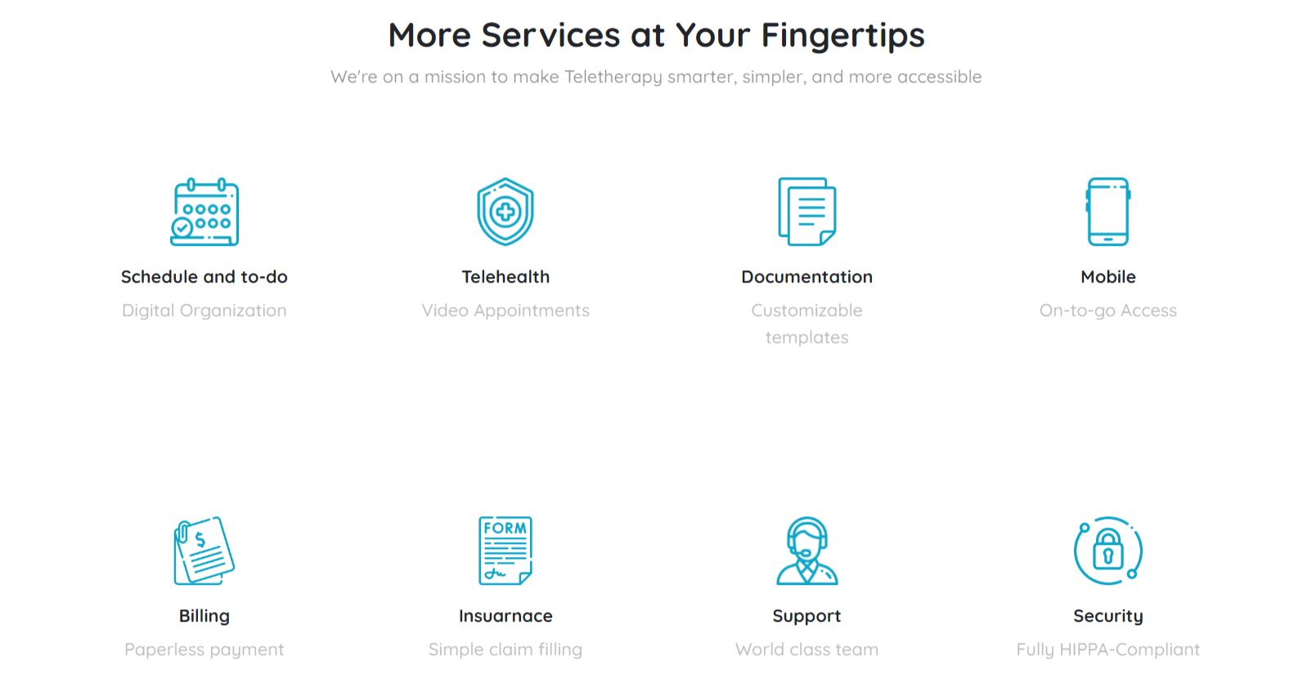

**Bug:** There is unnecessary space between the services that does not match the design.

1. **Extra Space Below Services and Division Panel:**

**Design:**

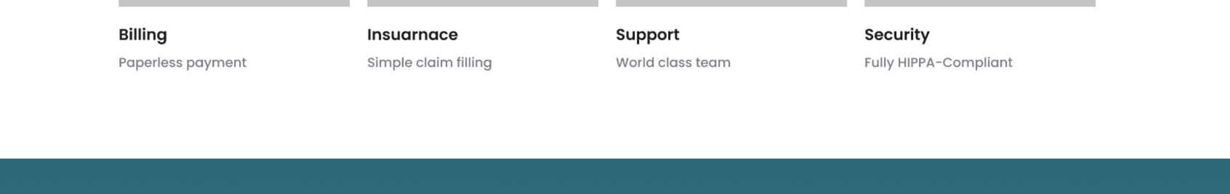

**Actual:**

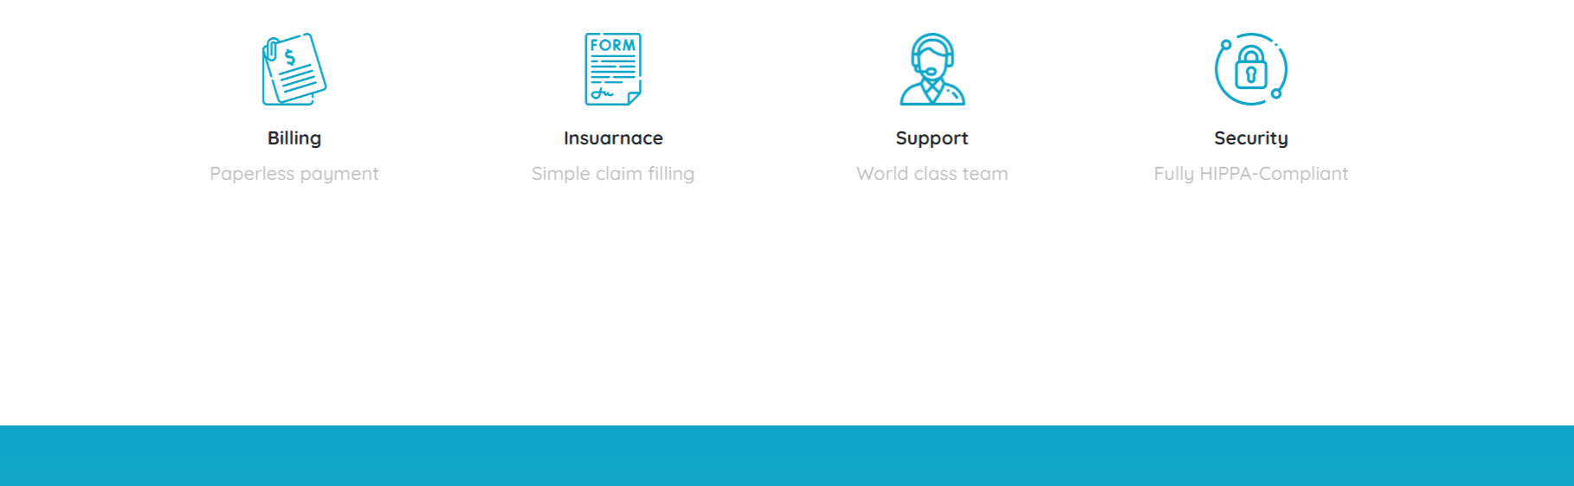

**Bug:** The space below the services and division panel differs between the design and actual implementation.

1. **Font and Heading Alignment Issue:**

**Design:**

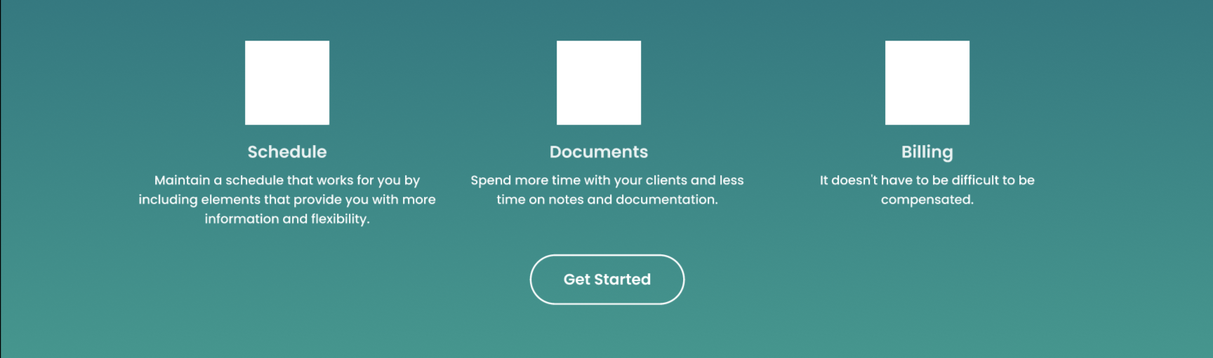

**Actual:**

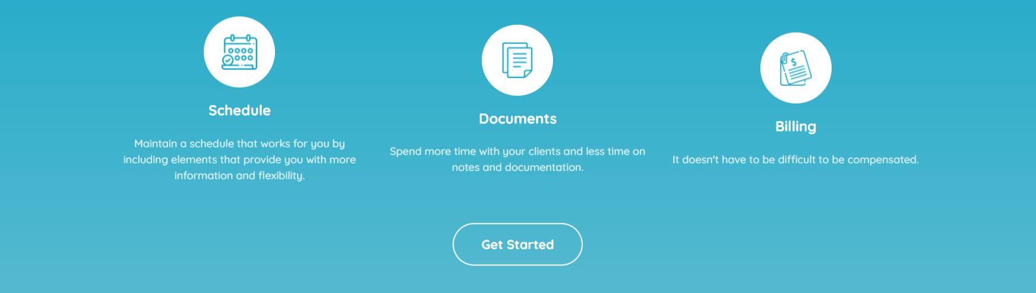

**Bug:** There is an issue with font and heading alignment between the design and the actual implementation.

1. **Placeholders Presence and Font style:**

**Design:**

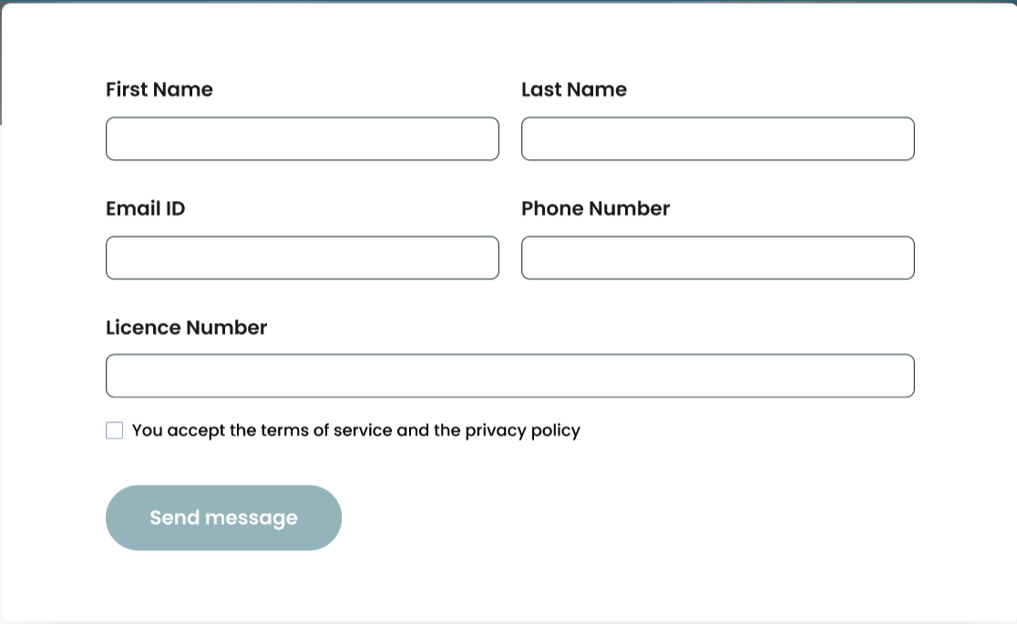

**Actual:**

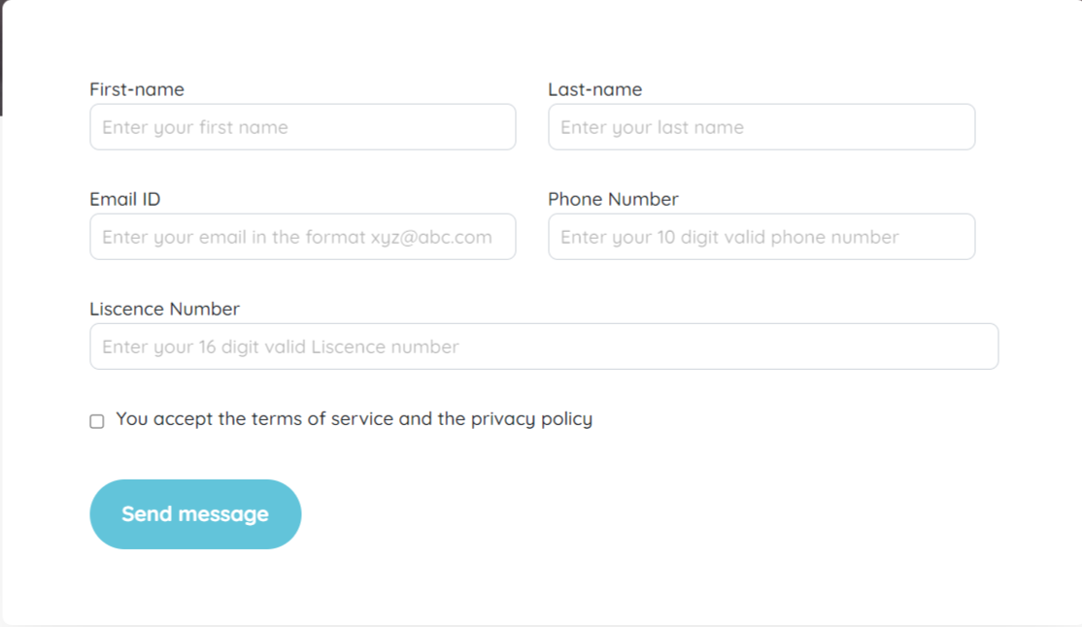

**Bug:** Placeholders are present in the actual implementation but are absent in the design.

1. **Spelling Error:**

**Design:**

**Actual:**

**Bug:** There is a spelling error in the word "license" in the actual implementation.

1. **Hyphen Between First Name and Last Name:**

**Design:**



**Actual:**



**Bug:** In the design, there is a hyphen between the first name and last name, whereas in the web implementation, it is absent.

1. **Space Inconsistency Below Fields and Textbox:**

**Design:**

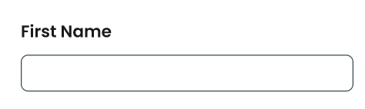

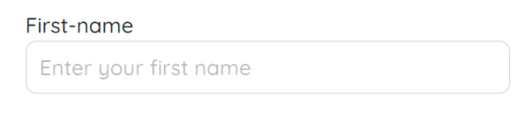

**Bug:** There is space below the fields and textboxes in the actual implementation.

1. **Font Weight Difference:**

**Design:**



**Actual:**

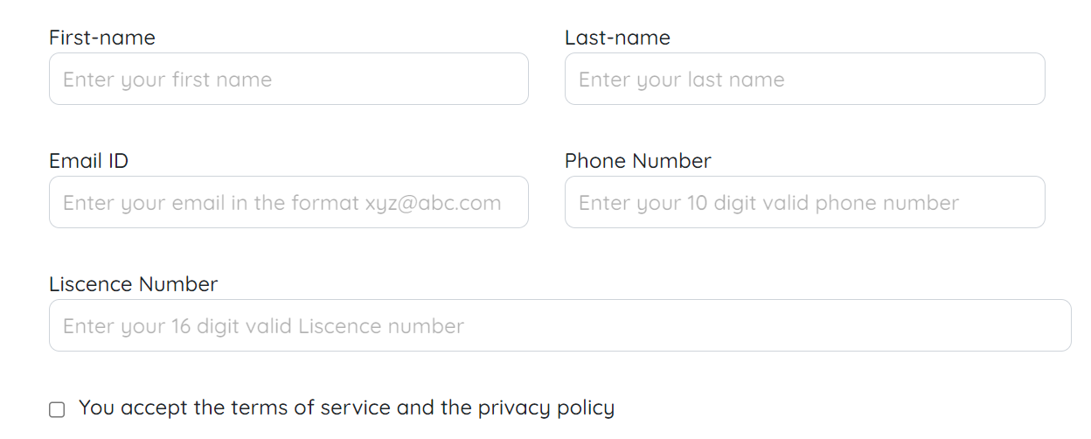

**Bug:** Fonts are bold in the design but regular in the web implementation.

1. **Send Message Button Size Difference:**

**Design:**

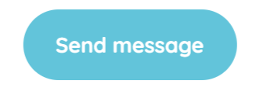**Actual:**

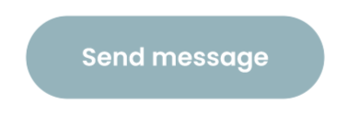

**Bug:** The size of the "Send Message" button differs from the design in the web implementation

1. **Option Selection Highlighting:**

**Design:**

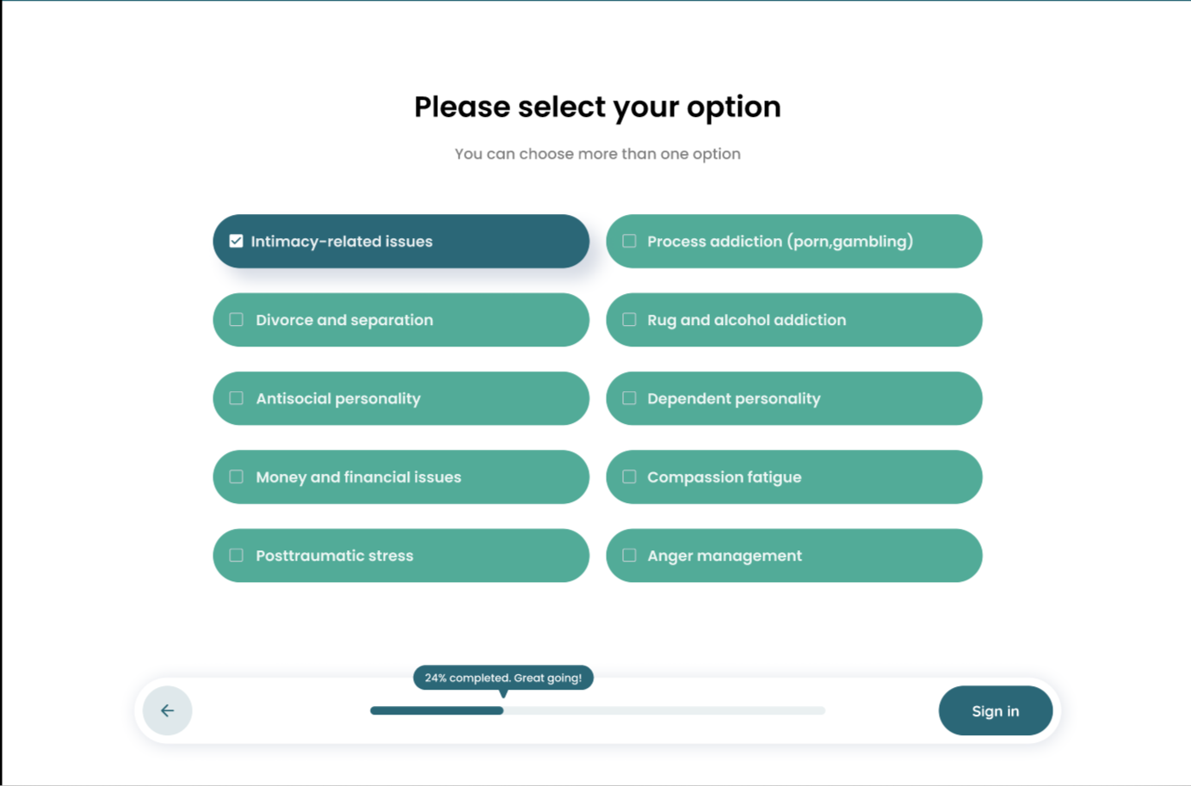

**Actual:**

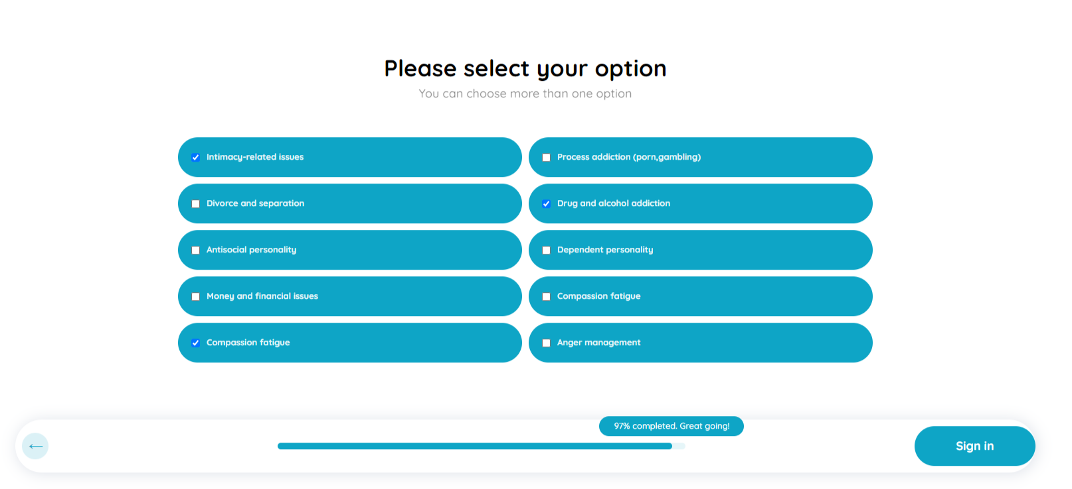

**Bug:** When selecting options in the web interface, they do not highlight as in the design; only checkboxes can be checked.

1. **Space Difference Between Options:**

**Design:**

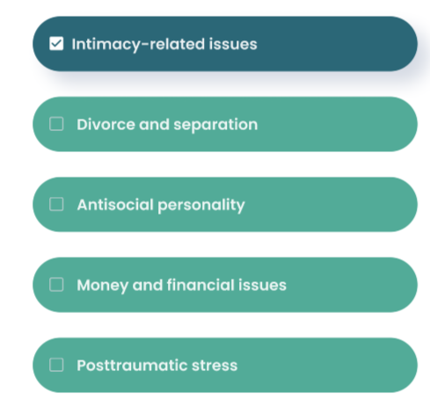

**Actual:**

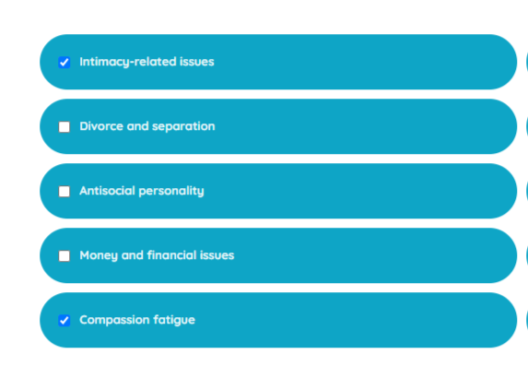

**Bug:** There is extra space between the options in the web implementation compared to the design.

1. **Vertical Space Inconsistency Between Options:**

**Design:**

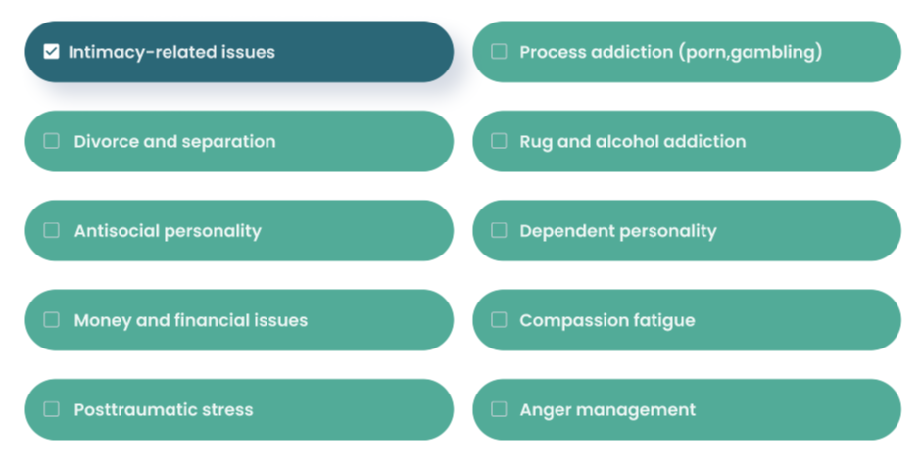

**Actual:**

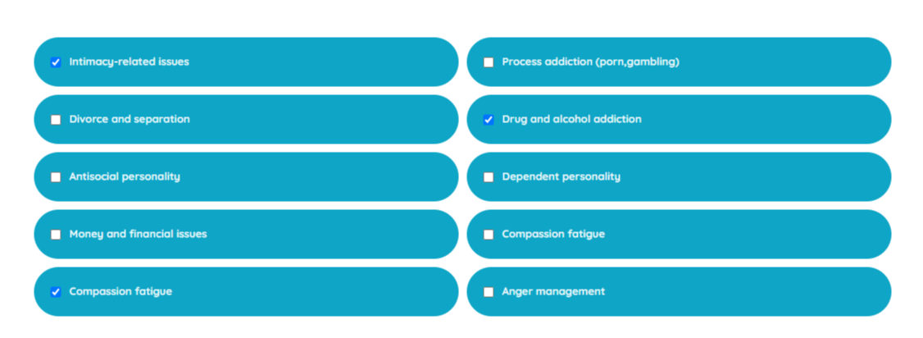

**Bug:** There is more vertical space between the options in the design compared to the web implementation.

1. **Percentage Show Difference:**

**Design:**

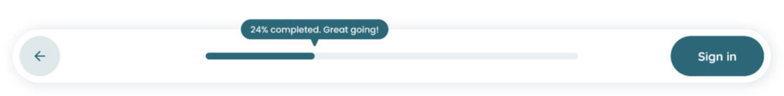

**Actual:**



**Bug:** In the design, there is a small arrow pointing downwards, which is not present in the web implementation.

1. **Space After Sign In Button:**

**Design:**

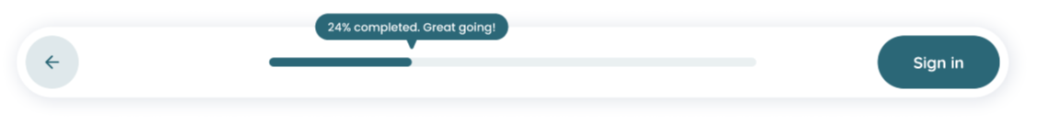

**Actual**



**Bug:** There is no space after the "Sign In" button in the web implementation, unlike in the design.

1. **Previous Page (arrow) Indicator Shape:**

**Design:**

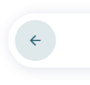

**Actual:**

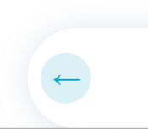

**Bug:** The arrow mark shape indicating the previous page in the web implementation is different from the design.

1. **Repeated Options:**

**Design:** 

**Actual:**



**Bug:** Options are repeated in the web implementation.

1. **Content Alignment Difference:**

**Design:**

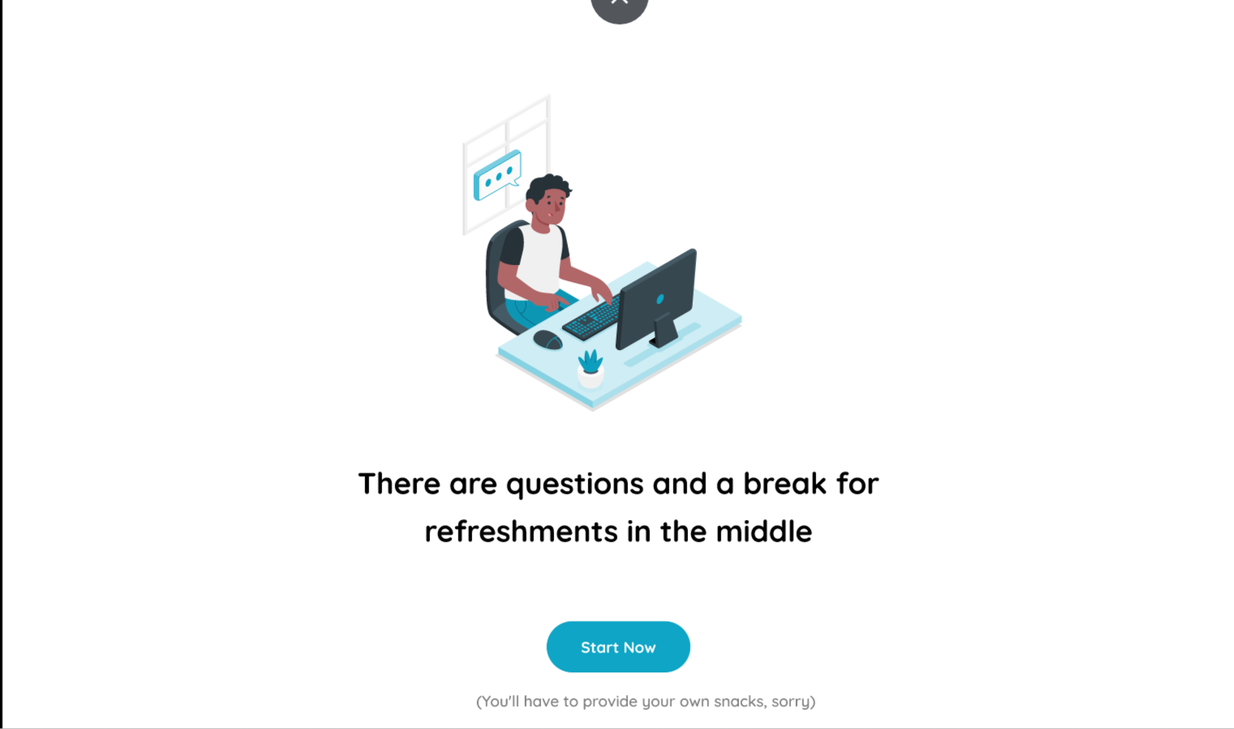

**Actual:**

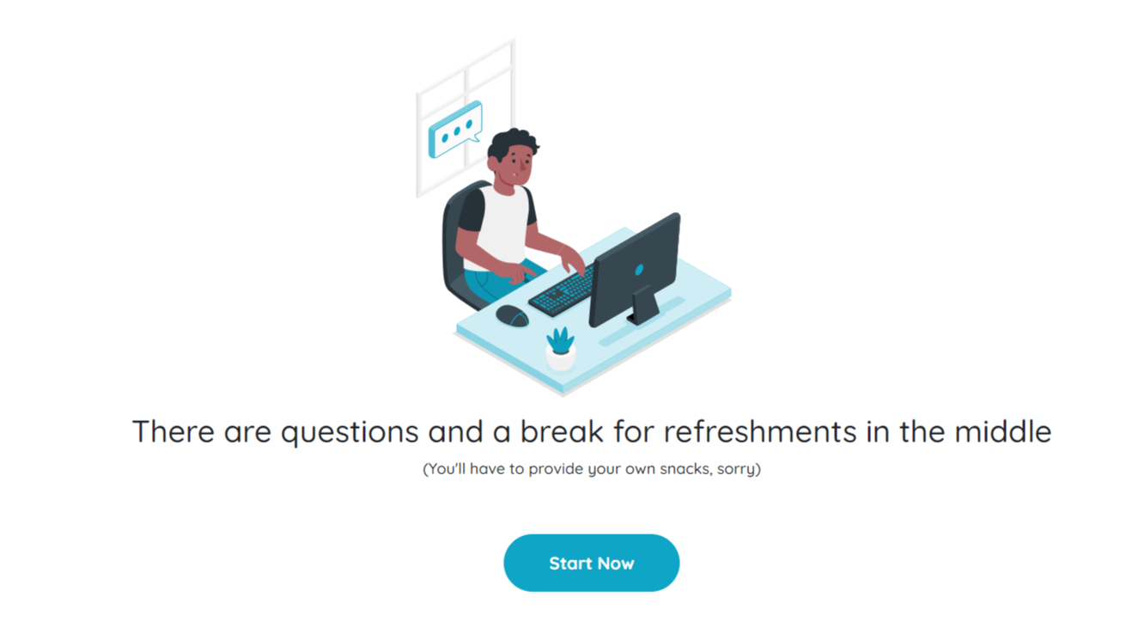

**Bug:** There is a difference in content alignment between the web implementation and the design.

**33. Font Weight Difference:**

**Design:**

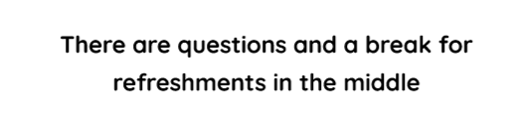

**Actual:**

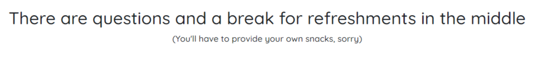

**Bug:** Fonts are bold in the design but regular in the web implementation.

1. **Curved Option Box Size Difference:**

**Design:**

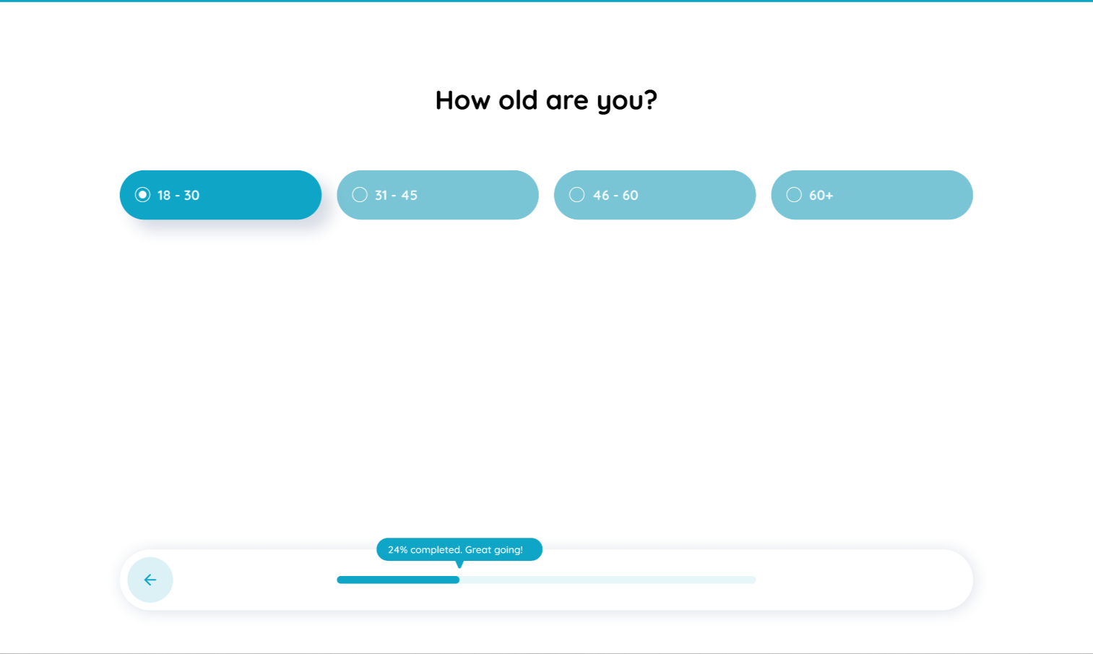

**Actual:**

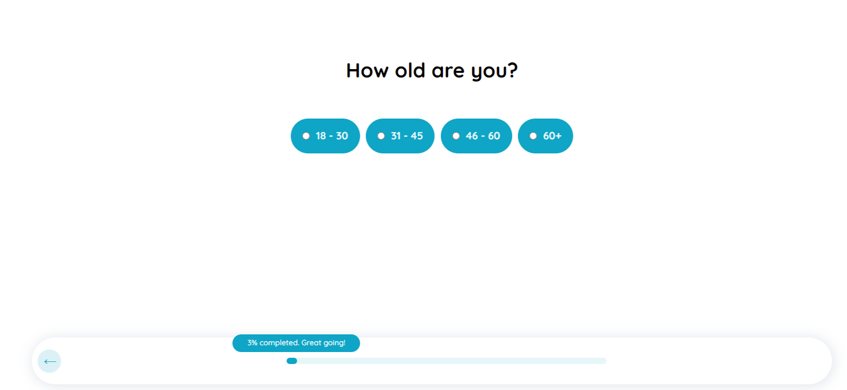

**Bug:** The size of the curved option box is smaller in the web implementation, fitting within the box, whereas it is larger in the design.

**Bug:** When selecting options in the web interface, they do not highlight as in the design; only checkboxes can be checked **(Repeated issue from # 26)**

1. **Cross Mark Color Difference:**

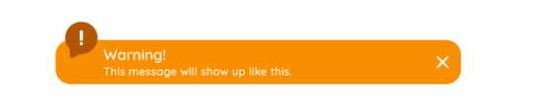**Design:**

**Actual:**

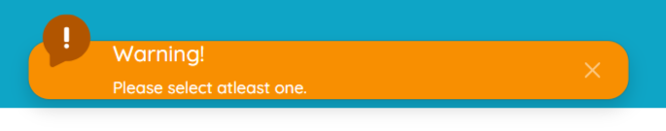

**Bug:** The cross mark is darker in the design but lighter in the web implementation.